1. [Machine learning workflows to estimate class probabilities for precision cancer diagnostics on DNA methylation microarray data](https://www.nature.com/articles/s41596-019-0251-6)

* **Used Technique / Ingenuity**
* Models overview
  + 3D maps of gray and/or white matter (deep learning models: six layer CNN, ResNet, and Inception V1)
  + vertex wise measurements from the surface-based processing (models BLUP and SVM)

|  |  |
| --- | --- |
| Model 1 | Best Linear Unbiased Predictor(BLUP) |
| Model 2 | Support Vector Regression |
| Model 3 | Six-Layer Convolutional Neural Networks |
| Model 4 | Specialized Six-Layer Convolutional Neural Networks for Younger and Older Subjects |
| Model 5 | ResNet |
| Model 6 | Inception V1 |

* Additional Experiments
  + Different Types of Model Combination: Linear Regression vs. Random Forest
  + Combining Seven (Identical) Convolutional Neural Networks or the Seven Best Epochs
  + Influence of the Type of Brain Features on Prediction Accuracy
* **Suitable Reason**

In this field, it’s very clearly on comparing 6 variety models which can help us to know the implementation what we learned in class.

Also can aware of the result between high level model and custom level model  
For linear regression and random forest, they trained the **ensemble algorithms** on a random subset. They repeated this process 500 times to get a bootstrap estimate of the SE of the MAE.

* The custom model in [1]

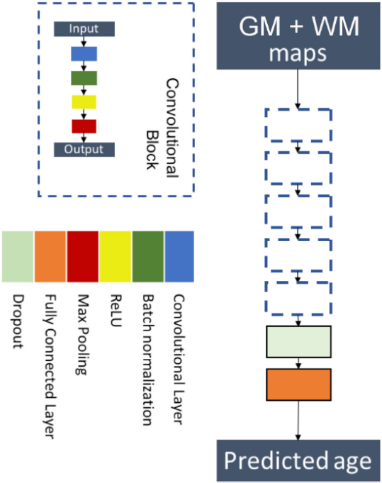

* Self-defined ResNet in [1]

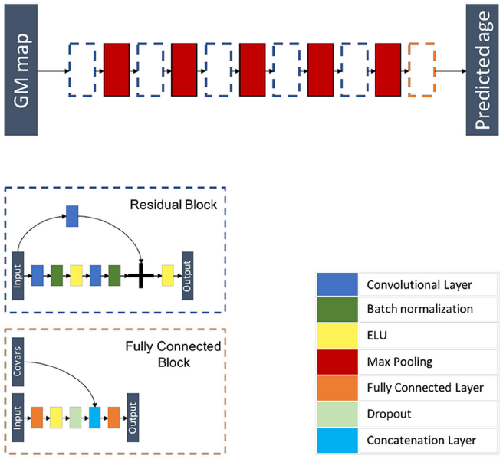

* Self-defined Inception V1 in [1]

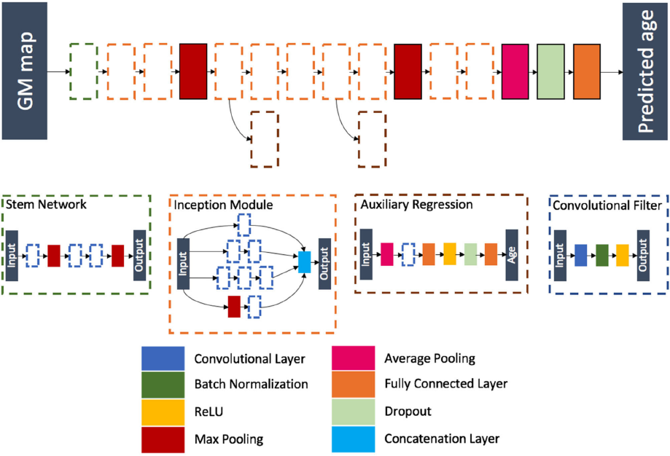

* The whole result of experience in [1]

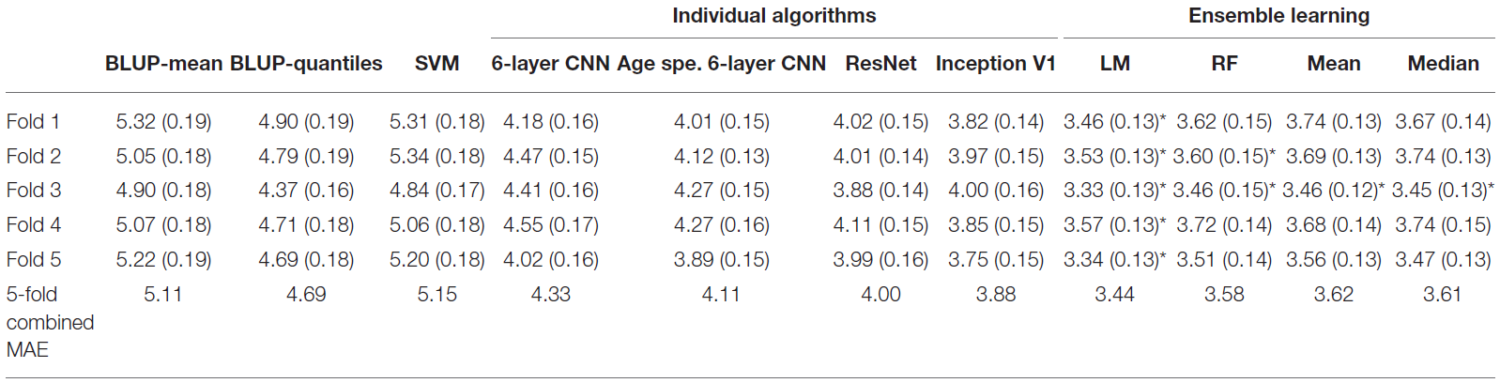

1. [Deep6mAPred A CNN and Bi-LSTM-based deep learning method for predicting DNA N6-methyladenosine sites across plant species](https://www.sciencedirect.com/science/article/pii/S1046202322001001)

* **Used Technique / Ingenuity**
  + The model is shown as below including input, feature extraction and classification
  + **Input**: map a DNA sequence of 41 nt into a binary vector with the one-hot encoding scheme. The feature extraction contained two paralleling parts
  + **Upper part**: mainly of one-dimensional convolution (1D CNN) layer and the batch normalization
  + **Lower part**: bidirectional LSTM (Bi- LSTM) layers and the attention mechanism. The Bi-LSTM was intended to extract contextual semantics of the sequences, while the attention mechanism was to catch the key information
* The flowchart of the Deep6mAPred

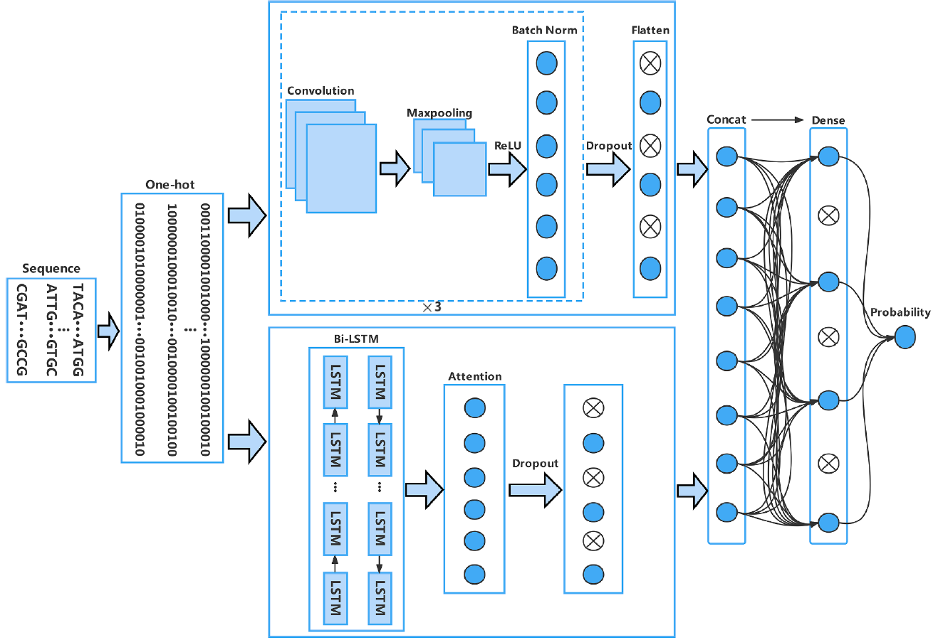

* The architecture diagram of LSTM

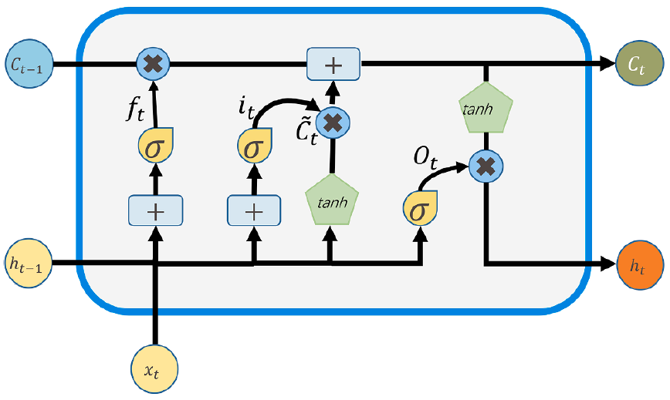

* **Suitable Reason**

The whole content in this paper has highly connection with Machine Learning Lecture, such as RNN, LSTM, architecture of normal CNN. And they can explained very clearly that why they used this custom model to achieve their goal. Furthermore, it has compared with other models of their performance on 6mA-rice-chen, F.verca and R.chinensis dataset very detailed.

1. [Ensemble Learning of Convolutional Neural Network, Support Vector Machine, and Best Linear Unbiased Predictor for Brain Age Prediction](https://www.frontiersin.org/articles/10.3389/fpsyt.2020.593336/full)

* **Used Technique / Ingenuity**
  + Model for classification

Random Forest, GLMNet, SVM(including e1071, which is a package of LibSVM in R language, LiblinearR, kernlab, Rgtsvm), and xgboost

* + Calibration Algorithm(i.e. post-processing):logistic regression(GLM function), BRGLM, GLMNet
  + Performance evaluation: HandTill2001
* **Suitable Reason**

The reason is as the same as [1] which also used various methods and compare it to other papers detailed.

* The reuslt in [3]

